TITLE PAGE

Vulnerability Assessment and Penetration Testing (VAPT) Report
Week 4 – Advanced Security Testing

Prepared By: Vaibhav Tripathi
Date: 10 April 2026

EXECUTIVE SUMMARY

This report presents the results of a comprehensive Vulnerability Assessment and Penetration Testing (VAPT) conducted on a controlled lab environment. The objective of this assessment was to identify security weaknesses, exploit vulnerabilities, and evaluate the overall security posture of the system.
The testing involved multiple phases including reconnaissance, scanning, vulnerability analysis, exploitation, and post-exploitation. Various tools such as Metasploit, Burp Suite, SQLMap, and Wireshark were utilized to simulate real-world attack scenarios.
During the assessment, several vulnerabilities were identified, including SQL Injection, Cross-Site Scripting (XSS), weak authentication mechanisms, and misconfigured services. These vulnerabilities were successfully exploited to demonstrate potential impact, including unauthorized data access and system compromise.
The findings highlight critical security gaps that could be exploited by attackers. Proper remediation measures such as input validation, secure coding practices, and system hardening are recommended to mitigate these risks and improve the overall security posture.

SCOPE OF TESTING

Target System: DVWA & Metasploitable2
IP Address: 192.168.154.129
Environment: Virtual Lab (Kali Linux)

Scope Includes:
- Web Application Testing
- Network Service Exploitation
- Database Testing
- Post-Exploitation Analysis

METHODOLOGY

The testing methodology followed a structured penetration testing approach based on industry standards such as PTES.
- Reconnaissance: Initial information gathering was performed to identify the target system, open services, and application structure.
- Scanning: Network scanning was conducted using tools like Nmap to identify open ports and running services.
- Vulnerability Assessment: The system was tested for known vulnerabilities such as SQL Injection, XSS, and weak authentication.
- Exploitation: Identified vulnerabilities were exploited using tools like Metasploit and SQLMap to gain unauthorized access.
- Post-Exploitation: After successful exploitation, further actions were performed to understand the impact, such as extracting data and maintaining access.

TOOLS USED

Kali Linux
Metasploit Framework
Burp Suite
SQLMap
Nmap
Wireshark
DVWA

VULNERABILITY FINDINGS

Finding ID | Vulnerability | Severity | Description
----------------------------------------------------------
F001 | SQL Injection | Critical | Database access gained
F002 | XSS (Reflected) | Medium | Script injection possible
F003 | XSS (Stored) | High | Persistent attack possible
F004 | Weak Authentication | Medium | Easy brute-force attack
F005 | Misconfigured FTP | Critical | Remote access via backdoor

EXPLOITATION DETAILS

During the exploitation phase, multiple vulnerabilities were successfully exploited to demonstrate their impact. SQL Injection was performed on the DVWA application using SQLMap, which allowed extraction of database contents including user credentials. The tool identified the backend database as MySQL and successfully dumped tables and password hashes.

Cross-Site Scripting (XSS) vulnerabilities were also identified and exploited. Reflected XSS allowed execution of scripts through URL manipulation, while stored XSS enabled persistent script execution affecting multiple users.

Additionally, a critical vulnerability in the VSFTPD service was exploited using Metasploit. The vsftpd 2.3.4 backdoor exploit provided remote command execution and opened a session on the target system, demonstrating complete system compromise.

These exploitation activities highlight the severity of vulnerabilities and their potential real-world impact.

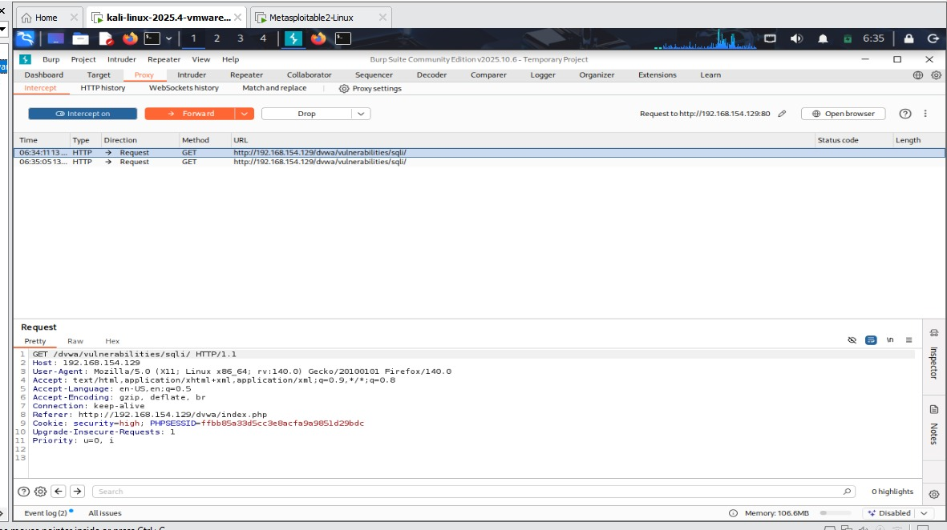

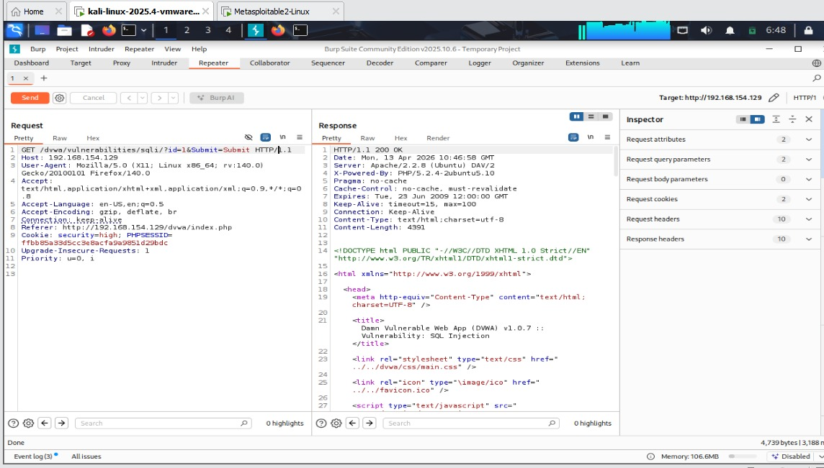

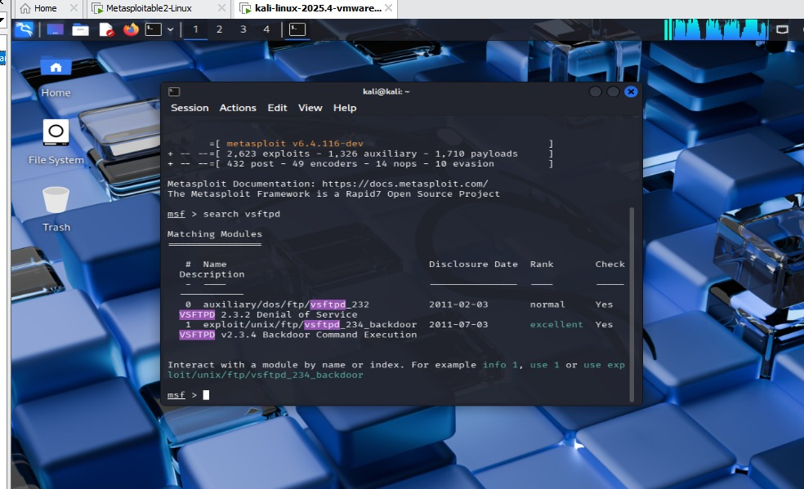

POST-EXPLOITATION

Post-exploitation activities were conducted to assess the extent of system compromise. After gaining access through Metasploit, a Meterpreter session was established, allowing interaction with the target system.

Sensitive data such as user credentials and system information was accessed, demonstrating the potential impact of the vulnerabilities. The attacker could maintain persistence, execute commands, and further escalate privileges.

These actions emphasize the importance of securing systems even after initial compromise, as attackers can leverage access for long-term exploitation.

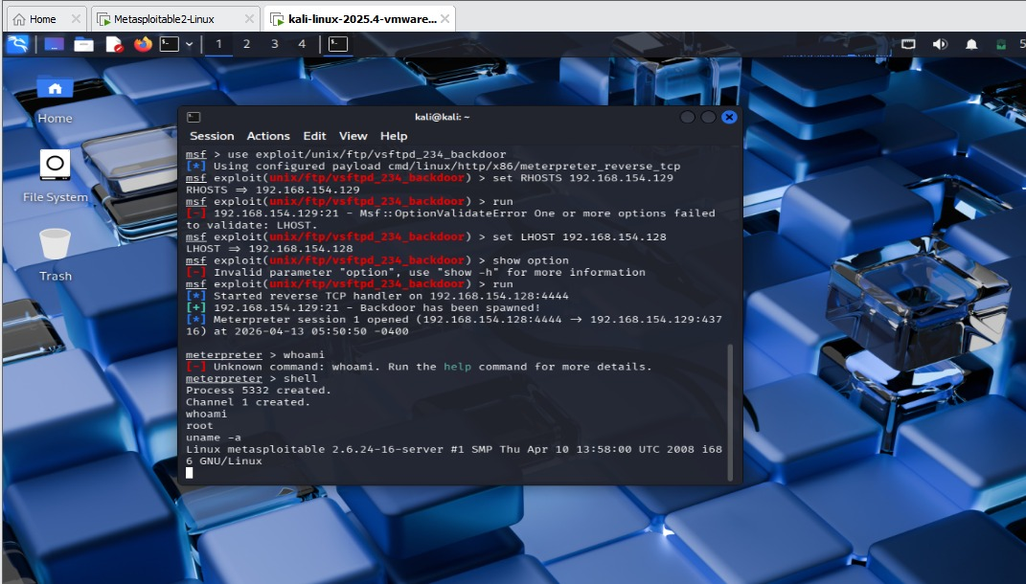

Risk Analysis
The identified vulnerabilities were analyzed based on their potential impact, likelihood of exploitation, and overall risk to the system. Risk levels were categorized into Critical, High, Medium, and Low based on industry-standard practices such as CVSS scoring.

Critical Risk
Critical vulnerabilities pose an immediate threat to system integrity and confidentiality. The SQL Injection vulnerability allowed direct interaction with the backend database, enabling attackers to extract sensitive information such as user credentials and application data. Additionally, the VSFTPD backdoor vulnerability allowed remote command execution, giving attackers full control over the system. Exploitation of such vulnerabilities can lead to complete system compromise, data breaches, and unauthorized access.

High Risk
High-risk vulnerabilities include Stored Cross-Site Scripting (XSS), which allows attackers to inject malicious scripts that persist on the server and affect multiple users. This can result in session hijacking, credential theft, and unauthorized actions performed on behalf of legitimate users. These vulnerabilities can significantly impact application integrity and user trust.

Medium Risk
Medium-risk vulnerabilities include Reflected XSS and weak authentication mechanisms. Reflected XSS requires user interaction but can still lead to phishing attacks and session theft. Weak authentication mechanisms, such as lack of account lockout or weak password policies, increase the risk of brute-force attacks and unauthorized access.

Low Risk
Low-risk issues include minor information disclosure and misconfigurations that may not directly compromise the system but provide useful information to attackers. These vulnerabilities can aid in reconnaissance and further exploitation.

Risk Impact Summary
The overall risk posture of the system is considered high, as multiple vulnerabilities can be chained together to achieve deeper system compromise. For example, an attacker could use XSS to steal session tokens, followed by SQL Injection to extract database information, and finally exploit system-level vulnerabilities to gain full control.
Proper prioritization of remediation efforts is essential to address critical and high-risk vulnerabilities first.

Remediation
To mitigate the identified vulnerabilities and strengthen the overall security posture of the system, the following remediation strategies are recommended:
Input Validation and Output Encoding
All user inputs should be strictly validated on both client-side and server-side. Input validation ensures that only expected data formats are accepted, reducing the risk of injection attacks. Output encoding should be applied to prevent execution of malicious scripts, thereby mitigating XSS vulnerabilities.
Use of Prepared Statements
SQL Injection vulnerabilities can be prevented by using parameterized queries or prepared statements. This ensures that user input is treated as data rather than executable SQL code.
Strong Authentication Mechanisms
Implement strong password policies, including minimum length, complexity requirements, and periodic password changes. Account lockout mechanisms should be enforced to prevent brute-force attacks. Multi-factor authentication (MFA) should be considered for enhanced security.
Patch Management and Updates
All software components, including web servers, databases, and services such as FTP, should be regularly updated to the latest versions. Known vulnerabilities, such as the VSFTPD backdoor, can be mitigated by applying security patches and removing outdated services.
Secure Configuration
Disable unnecessary services and ports to reduce the attack surface. Default credentials should be changed, and proper access controls should be enforced. Secure configurations help prevent unauthorized access and exploitation.
Web Application Firewall (WAF)
Implementing a WAF can help detect and block malicious traffic, including SQL Injection and XSS attempts. While not a complete solution, it adds an additional layer of defense.
Logging and Monitoring
Enable detailed logging and real-time monitoring to detect suspicious activities. Security Information and Event Management (SIEM) systems can be used to analyze logs and identify potential attacks.
Principle of Least Privilege
Users and applications should be granted only the minimum level of access required to perform their tasks. This reduces the impact of compromised accounts or services.
Security Awareness
Developers and administrators should be trained in secure coding practices and security best practices to prevent vulnerabilities during development.
Continuous Security Testing
Regular vulnerability assessments and penetration testing should be conducted to identify and fix new vulnerabilities. Security is an ongoing process and requires continuous monitoring and improvement.
By implementing these remediation strategies, the organization can significantly reduce the risk of exploitation and improve the overall resilience of the system against cyber threats.

CONCLUSION
The VAPT assessment successfully identified multiple critical vulnerabilities within the target system. The exploitation of these vulnerabilities demonstrated how attackers can gain unauthorized access, extract sensitive data, and compromise system integrity.
The findings emphasize the importance of secure coding practices, regular security assessments, and proper system configuration. Implementing the recommended remediation measures will significantly reduce the risk of attacks and improve the overall security posture of the system.
200-WORD CAPSTONE REPORT
This project demonstrates a complete Vulnerability Assessment and Penetration Testing (VAPT) cycle conducted on a controlled lab environment. The process began with reconnaissance and scanning to identify open ports and services. Tools like Nmap and Nikto were used to gather information about the target system.
During the vulnerability assessment phase, multiple security issues such as SQL Injection and Cross-Site Scripting (XSS) were identified. These vulnerabilities were then exploited using tools like SQLMap and Burp Suite, allowing unauthorized access to sensitive data. Additionally, Metasploit was used to exploit a known backdoor vulnerability in the VSFTPD service, resulting in remote command execution.
Post-exploitation activities demonstrated the potential impact of these vulnerabilities, including data extraction and system compromise. Proper remediation strategies were suggested, including input validation, patch management, and secure configurations.
Overall, this project highlights the importance of regular security testing and demonstrates how vulnerabilities can be exploited if proper security measures are not implemented.

